Creating, Installing and Exporting User Certificates

Creating/Installing a User Certificate:

- On a city computer open Internet Explorer and go to the url https://msnet.ci.bremerton.wa.us/certsrv

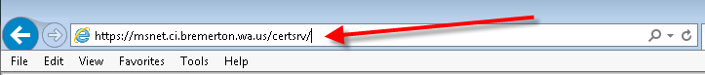
- Under “Select a task” choose “Request a certificate”.
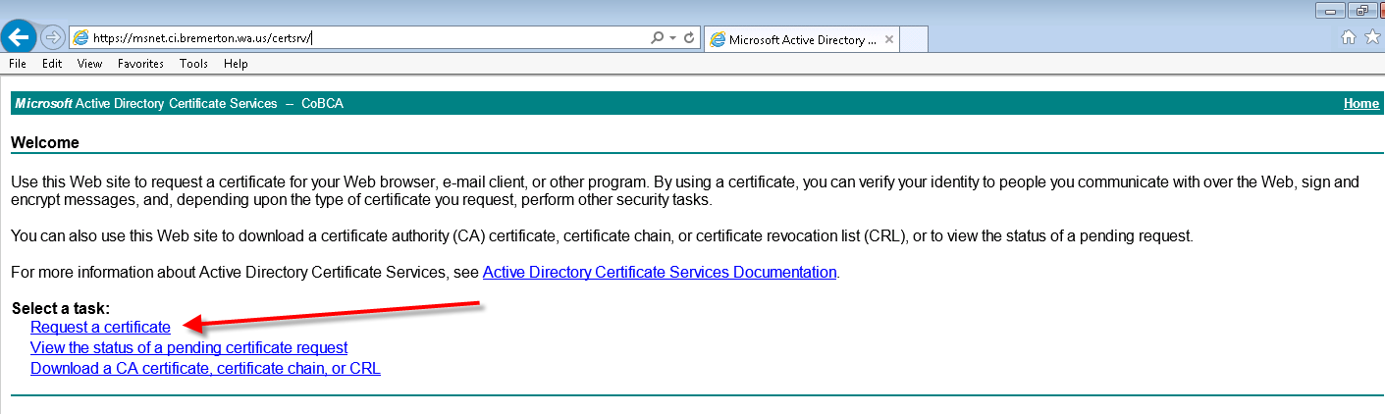
- Under “Request a Certificate” select “User Certificate”.
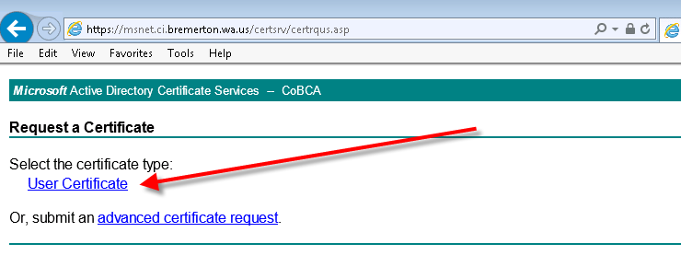

- A confirmation window should pop up, choose “Yes”.
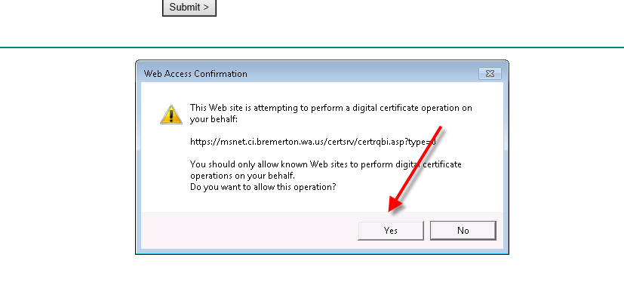
- Under “User Certificate – Identifying Information” choose “Submit”.
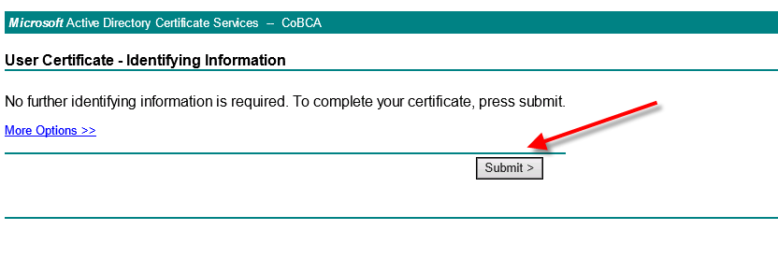
- Choose “Yes” in the next “Confirmation” window.
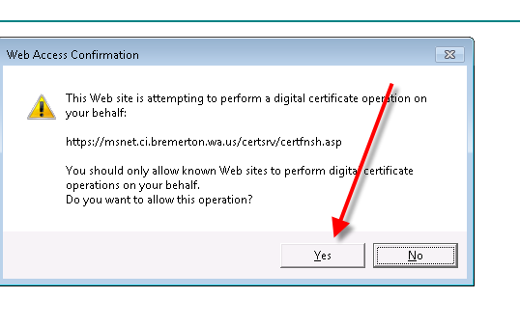

- Under “Certificate Issued” choose “Install this certificate”
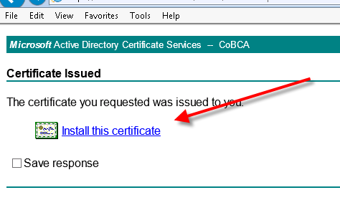
- You should get a “Certificate Installed” confirmation.

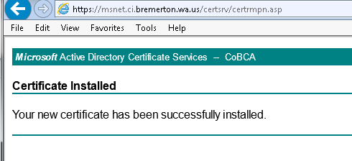

Exporting a User Certificate
- In Internet Explorer click “Tools” in the “Menu Bar”. If you do not see the “Menu Bar” there is a “Tools” drop-down menu 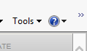 on the right side of the web browser’s toolbar.
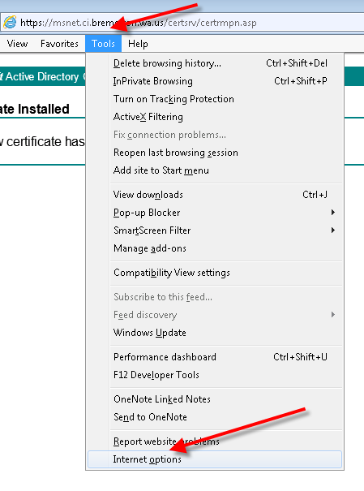

- In the “Internet Options” window click the “Content” tab then the “Certificates” button.
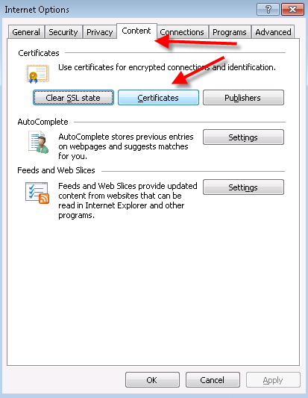

- High-light the certificate you would like to export and click the “Export” button.
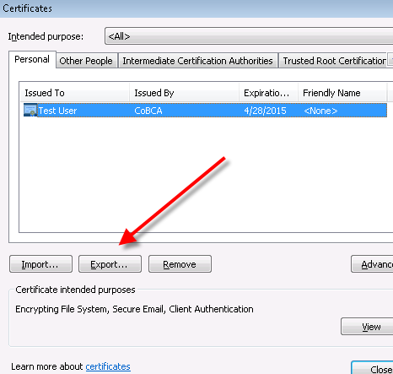
- In the “Export Wizard” window, click next.
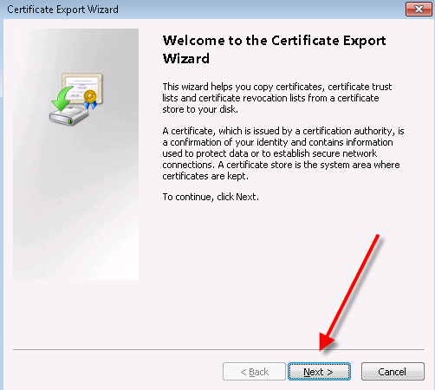

- In the “Export Wizard” click the “Yes, export the private key” option button and then click “Next”.
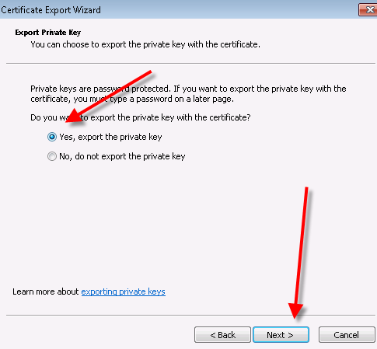
- Under “Personal Information Exchange…” choose “Include all certificates in the certification path…” and “Export all extended properties” options and click “Next”
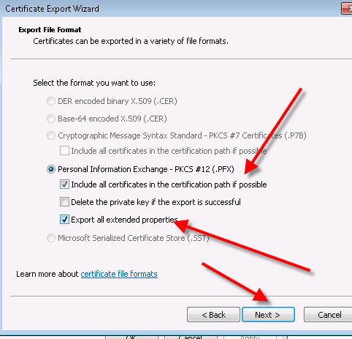
- In the “Export Wizard” window enter and confirm a password (you will need this password to import into other systems) and click “Next”.
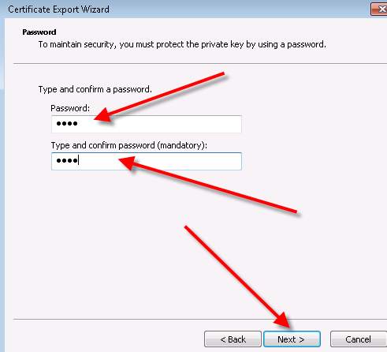
- Choose the drive and folder to export to, if you will be exporting this to another machine put it on a thumb drive. Click “Save”.
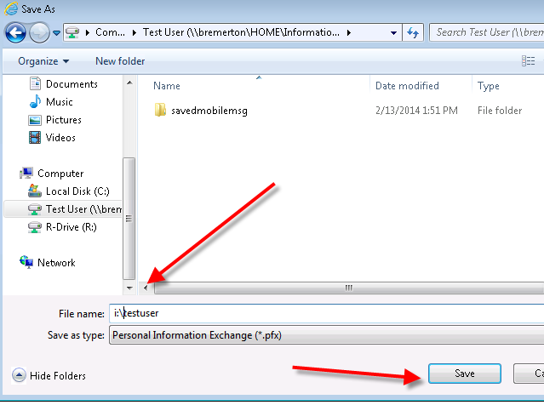

- In the “Export Wizard” window, verify the “File Name” and click “Next”.
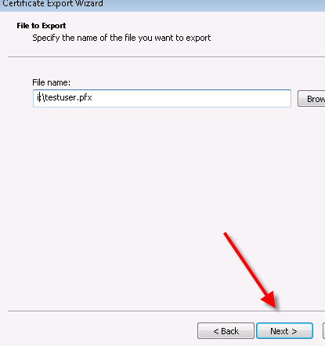
- Click Finish, an “Export Successful” window should pop up, click “OK”.
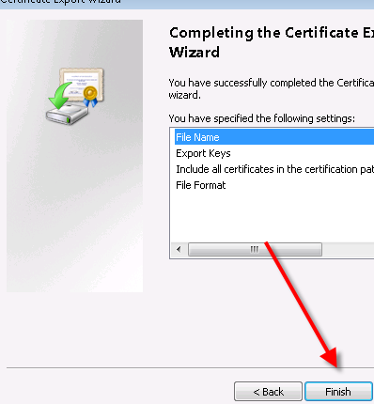
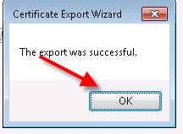
- Click close then OK in the Certificates and “Internet Options” windows. Exporting of certificate is complete.

